# DQ Monitoring Dashboard

## Prepare Demo on Training Virtuallab

To ensure that DQ Dashboard demo works as desired follow the steps below to load the data into memory and to run the Studio Flows to load the DQ Dashboard tables.

1. Fork the following repository: <https://github.com/paulvanmol/dqdashboard.git> to your personal git account
2. Clone the Repository from SAS Studio

Create a new empty folder dqdashboard:

Create a new git profile:

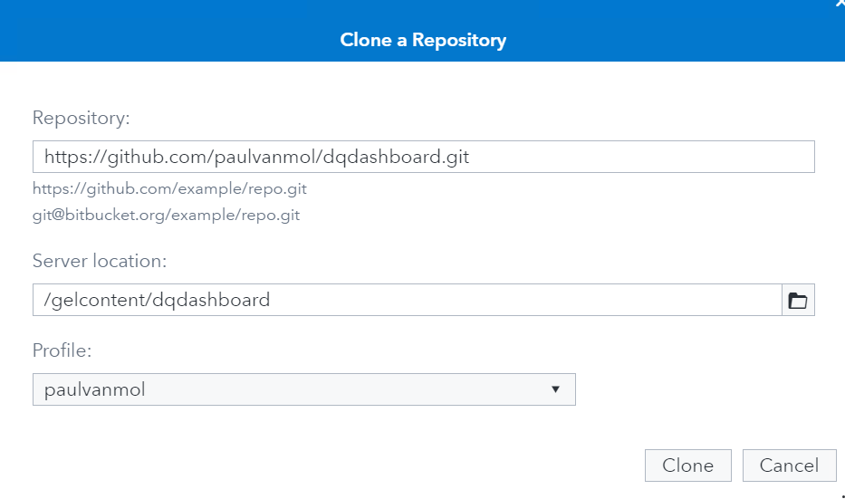

1. Download the required files from the dqdashboard folder:
   1. Packages/DQDashboard.json package from SAS Studio to your Downloads folder.
   2. Data/ADDRESS.xlsx, PERSON.xlsx, DQ_SCORE_HIST_RAW.xlsx
2. Import DQDashboard.json package in SAS Environment Manager
   1. Login as sasadm + lnxsas to have administrative privileges:
   2. Select Manage Environment:
   3. Select Import tab
   4. Import the DQDashboardPublic.json
   5. Map the Target Server to cas-shared-default, Map the Target Library PUBLIC, WORK CAS Library to the Public CAS Library:

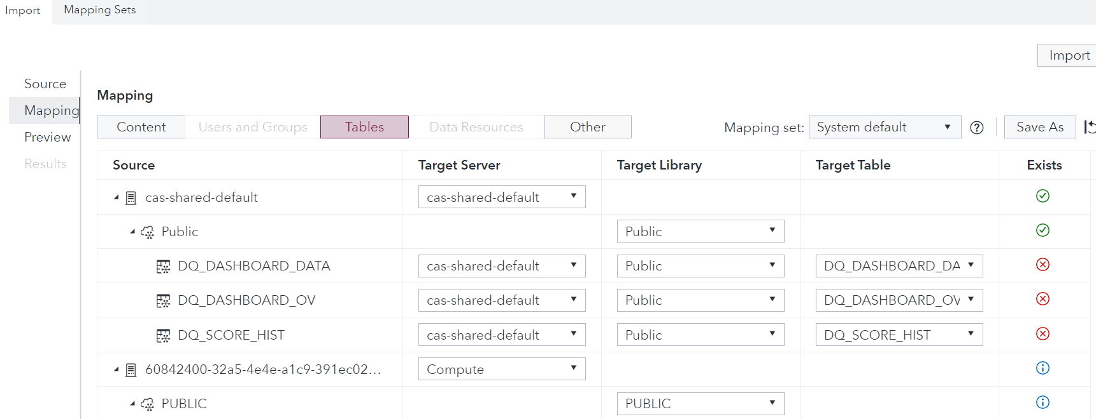

* 1. Other tables should map to Compute, Public and WORK libraries:

* 1. Check if Import is successful:

Upload the data to SAS Studio Explorer:

Upload the data of the dqdashboard repository to the home directory of the student:

* Either by doing a Git Clone in SAS Studio to the /gelcontent/dqdashboard folder
* Or by using the upload Button in the Explorer:

Go to SAS Studio (Develop Code and Flows)

1.1. Go to location: SAS Content/GTPPub/Data Management/DQ Dashboard/SAS Programs

1.2. Open and run SAS job: Load tables into memory.sas

cas casauto;

%let outcaslib=PUBLIC;

%let incaslib=GTPPUB;

%let path=/gelcontent/dqdashboard;

proc cas;

session casauto;

table.dropcaslib /caslib="&incaslib" quiet=true;

table.addCaslib /

caslib="&incaslib"

description="Monitor data"

dataSource={srctype="path"}

path="&path/data";

table.dropTable /

caslib= "&outcaslib",

name= "ADDRESS",

quiet= True;

run;

table.loadTable /

caslib= "&incaslib",

path="ADDRESS.xlsx",

casout={

caslib="&outcaslib",

promote= True

};

run;

table.dropTable /

caslib= "&outcaslib",

name= "PERSON",

quiet= True;

run;

table.loadTable /

caslib= "&incaslib",

path="PERSON.xlsx",

casout={

caslib="&outcaslib",

promote= True

};

run;

table.dropTable /

caslib= "&outcaslib"

name= "DQ_SCORE_HIST_RAW",

quiet= True;

run;

table.loadTable /

caslib= "&incaslib",

path="DQ_SCORE_HIST_RAW.xlsx",

casout={

caslib="&outcaslib",

promote= True

};

run;

quit;

1.3. Go to location: SAS Content/Public/Data Management/DQ Dashboard/Dashboard Flows

1.4. Open and run flows:

* Monitor_Person.flw
* Monitor_Address.flw
* Write_Dashboard_Tables.flw

2. Go to SAS Drive (Share and Collaborate)

2.1. Open Dashboard: DQ Dashboard in location: SAS Content/Public/Data Management/DQ Dashboard/Dashboard to ensure the Dashboard data got generated correctly.